**Worksheet: *have* or *has***

***Has*** is used with singular subjects (he, she, it).

Example: ‘She has a cat.’

Explanation: ‘Has’ is used because ‘she’ is a singular subject.

**Have**: Used with I, you, we, they, and plural subjects.

Example: ‘They have a dog.’

Explanation: ‘Have’ is used because ‘they’ is a plural subject.

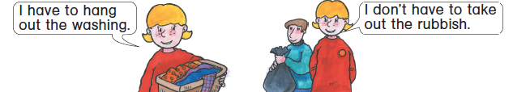

**1. Write *have* or *has* to complete the sentences.**

1. My room ___________ wooden floor.

1. I ____________ a car.

1. Abid ___________ a toothbrush for his cat.

1. I _____________ a collection of stickers.

**2. Circle *have to* or *has to*.**

1. I have to / has to wash the dishes.

1. He have to / has to take out the rubbish.

1. She have to / has to brush the cat.

1. I have to / has to wash the car.

1. Terry have to / has to tidy his bedroom.

**3. Write sentences about 5 things you have in your room.**

1. __________________________________________________________.

2. ____________________________________________________________.

3. ____________________________________________________________.

4. ____________________________________________________________.

5. ____________________________________________________________.