**Worksheet – Asking Questions**

When we want to find out information, we can ask questions using words called ‘question words’ or ‘wh’ words. Some of these words are ‘what,’ who,’ when,’ ‘where,’ and ‘how.’ We also use words like ‘is’ and ‘are’ to ask questions.

**Examples:**

Is: Is it raining?

Are: Are you upset?

What: What is your name?

Explanation:

Using these words at the beginning of a sentence helps to turn it into a question.

**Is**: When we start a sentence with ‘Is’, we are asking about something. Example: **‘Is it raining?’** means we want to know if rain is falling.

**Are**: When we start a sentence with ‘Are,’ we are asking about someone or something. Example: ‘**Are you upset?’** means we want to know if the person is feeling sad or angry.

**What**: When we start a sentence with ‘What,’ we are asking for specific information. Example: **‘What is your name?’** means we want to know the person's name.

1. **Fill in a colour in the box with the correct use of is/there. Then answer the questions in the spaces given below. The first one has been done for you.**

How many bowls is there? How many bowls are there?

____________________________________ **There are three bowls.**

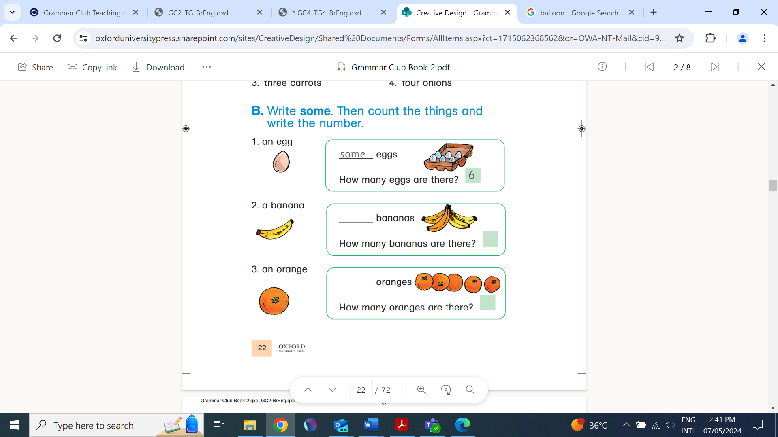

How many eggs is there? How many eggs are there?

__________________________________ ______________________________

How many the bananas are there? How many the bananas is there?

________________________________________ _________________________________

How many oranges are there? How many oranges is there?

___________________________________ _____________________________

How many kites is there? How many kites are there?

___________________________________ _____________________________

1. **Complete the information in the table below by asking your friends the following questions**.

For example: When were you born?

When…? What…? How…? Where…? Who…?

|  |  |  |  |  |  |
| --- | --- | --- | --- | --- | --- |
| **Name** | **date of birth** | **favourite colour** | **height** | **city** | **favourite teacher** |
| Amjad | 03/05/17 | Orange | 128.2 cm | Karachi | Miss Saba |
|  |  |  |  |  |  |
|  |  |  |  |  |  |
|  |  |  |  |  |  |
|  |  |  |  |  |  |