**Worksheet: Position Words (Prepositions)**

A **preposition** is a word that tells us where something is or when something happens.

Examples:

**In:**

Sentence: The cat is in the box.

Explanation: ‘In’ tells us where the cat is.

**On:**

Sentence: The book is on the table.

Explanation: ‘On’ tells us where the book is.

**Under:**

Sentence: The dog is under the bed.

Explanation: ‘Under’ tells us where the dog is.

**1. Match the sentence with the correct picture.**

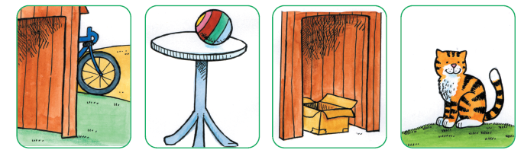 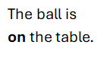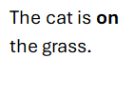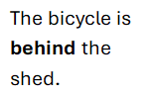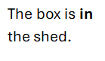

**2. Look at the pictures above and tick the correct place.**

1. The cat is in the shed. ___

     on the grass. ___

2. The ball is on the table. ___

behind the tree. ___

3. The bicycle is in the shed. ___

Shape behind the shed. ___

**3.  Circle  the correct word.**

a. Where is Tim?

He is  **behind  /  in**  the tree.

1. Where is Sally?  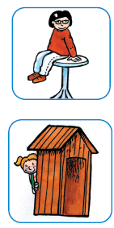

She is **on  /  in** the table.

1. Where is Jack?  A person riding a bicycle

   Description automatically generated

He is **behind  /  on** the bicycle.

 d.Where is Lisa?

She is **in  /  behind** the shed.