Worksheet: Articles – a / an

‘A’ - We use ‘a’ when talking about one thing.
For example, ‘a cat’ or ‘a ball.’
‘An’ - We use ‘an’ when talking about one thing that starts with a vowel sound (like a, e, i, o, u).
For example, ‘an apple’ or ‘an elephant.’
1. Circle the correct word.

a.  a / an book

b. 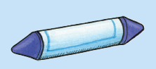 a / an crayon

c. 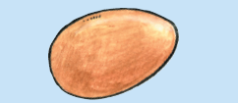 a / an egg

d. 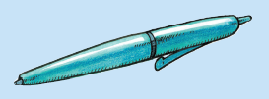 a / an pen

e. 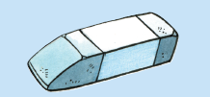 a / an eraser
f. 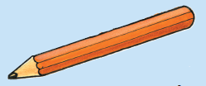 a / an pencil

g.  a / an orange

h. 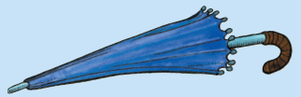 a / an umbrella

2. Write the correct words besides ‘a’ and ‘an’.
pen
egg
umbrella
ruler
apple
chair
rubber
orange
book
pencil
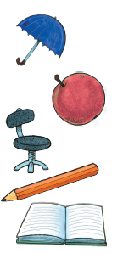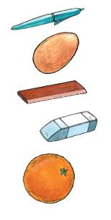

1. a __________________
2. a __________________
3. a __________________
4. a __________________
5. a __________________
6. a __________________
7. an _________________
8. an _________________
9. an _________________
10. an ________________

