**Worksheet – Opposites**

**Opposites** are words that have completely different meanings.

Hot ↔ Cold

Explanation: ‘Hot’ describes a high temperature, while ‘cold’ describes a low temperature. The words contrast each other by showing two different extremes of temperature.

**1. Write the opposites of the following words.**

1. slow  ***fast***

2. close __________________

3. short __________________

4. light ___________________

5. quiet ___________________

6. hot ___________________

7. love ___________________

8. heat ____________________

9. calm ____________________

10. laugh __________________

**2. Rewrite the passage using the correct opposites from the box below.**

There once was an **angry** boy named Ali who lived in a **small** house with his parents. Every day, Ali greeted everyone with a **frown**. He **kept** his toys and snacks to himself. Ali’s parents always stayed **upset** withhis **bad** behaviour and often **punished** him for being a **rude** boy.

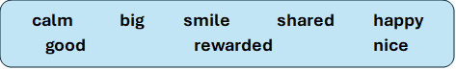

There was once a **happy**boy... **__________________________________________________________________________________________________________________________________________________________________________________________________________________________________________________________________________________________________________________________________________________________________________________________________________________________________________________________________________________________________________________________________________________________________________________________________________________________________**