**GUIDE TO ACCESS DIGITAL RESOURCES**

1. **Click the link to download.**

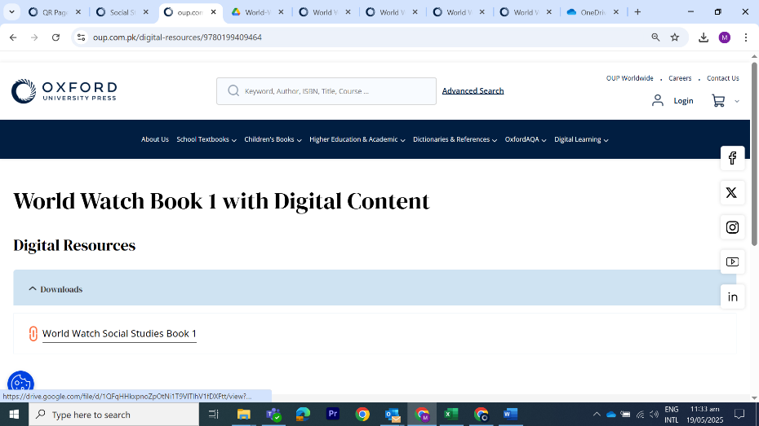



1. **Download the zip folder.**
2. **Extract all content.**
3. **Click on Play**

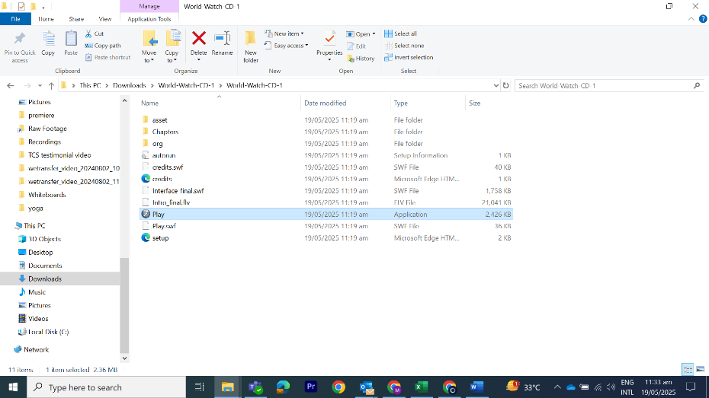

1. **You now have access to your Digital Content.**
2. **Happy Learning!**